GivePulse: A User Handbook
Resource for community parners, academics, and volunteers
Presented by
Bethany McCurdy
Ashton Chapman, Ph.d.
Joseph Lee, ph.d.
2019
Welcome to

Creating a network of people, communities and ideas

What is GivePulse?
The mission of GivePulse is to enable users to lift their community to new heights by providing a platform through which they can track and measure the impact of their teaching, research, learning, or volunteerism in their local communities.
Why Use GivePulse?
GivePulse has multiple features that can be utilized to achieve different goals. With GivePulse, you can manage groups, events, and members/volunteers to measure impacts that align with your mission, group, department, or school. Whether you’re a student, faculty or staff person, or community member, GivePulse can act as a hub for you to search for and engage with organizations you care about! GivePulse is your one-stop shop for collaborating with members of your professional network, as it allows you to communicate via message boards, advertise outreach opportunities, and approve and edit submitted projects, events, and opportunities. GivePulse allows you to monitor the influence of your work through automatic data collection, which means you can use GivePulse to systematically track and evaluate the effectiveness of your outreach efforts. Get started with GivePulse today to see how easy it can be to connect to colleagues, engage with your community, and track your impacts!
Benefits of GivePulse
- Engage with your community by connecting with community partners that share an interest and drive for service, leadership, and community outreach
- Coordinate and customize the work of a group, course, or community partnership in ways that best meet your needs
- Quickly advertise and/or locate community service projects and community events
- Facilitate registration or placement assignment to projects/events you are hosting
- Easily track and validate the work/service responsibilities and the impact this work is having in the community with GivePulse’s built-in data tracking capabilities
- Pull reports and analyze the collective impact of your work by topic area, geographic location, or other indicators of interest

Navigation

Getting Started………………………………………………………………………………..……........................ 3 Key terms………………………………………………………………………………………………..…….. 3
Creating an account and logging in………………………………………………………..…….. 4 Creating your profile..………………………………………………..…………………………..……… 6
GivePulse for Community Leaders and Partners …………………………………………….……. 7 Creating groups………………………………………………..……………………………………….….. 7
Events – Opportunities for volunteerism……………………………………………………….. 9
Creating and tracking impacts………………………………………………………………………. 11
Managing members and volunteers……………………………………………………………… 15
GivePulse for Teaching and Research……………………………………………………………………. 16
Creating a class……….………………………………………………..…………………………………... 17
Managing members and impacts………………………………………………………………….. 19
Events – Opportunities for research………………………………………………………………. 22
Breakdown of Service Learning Features……………………………………………………….. 24
GivePulse for Students and Volunteers………………………………………………………………..... 26
Joining a group………………………………………………..……………………………………………. 27
Events – Opportunities for community engagement……………………….…………….. 29
Joining a class………………………………………………..…………….……………………………..…. 32
Events – Opportunities for research………………………………...…………………………….. 34
Impacts………………………………………………..………………………………………………………… 35
Extended Glossary………………………………………………..…………………………………………………. 40
Video Tutorials………………………………………………..………………………………………………………. 45
Key Terms
Throughout this document, you will run into terms that describe main features of GivePulse. To aid you in this tutorial, refer to this page for descriptions of these terms. For a more detailed glossary of terms, refer to the extended glossary at the end of this document.
Events
If you manage an organization or group, it is likely that you will be creating and managing private or public events. If you are a volunteer, you will likely use GivePulse to search for events that are looking for volunteers. To help organize volunteers, students, and/or other members of an event you want to host, you can create an Event for it through GivePulse. Creating Events will be helpful for you to keep track of each person that has signed up to attend or volunteer and the “impacts” they achieve through your event (and vice-versa for users looking to track their experience and hours). Events can be any activity that is happening within your organization or between your organization and the community, such as hosting a county fair through 4-H, setting up a blood drive, or setting up a booth at a local convention to spread information about your organization (or, if you are a researcher, a weekly team meeting would count as an event!)
Impacts
Every time you volunteer, serve, or donate to an event, you are making an impact! Impacts help provide data for reporting purposes, to get feedback on the quality of an experience via user report, and to better understand the impact of work happening in the community. Impacts can range from any direct interaction between organizations/students/volunteers and events or can be individual or smaller group achievements, like doing research, setting up office hours, having a meeting, training yourself or others, handing out marketing materials, etc. Impacts are a way to log all the activities that happen within a group. Different groups may report different types of impacts. One example of an impact that students log, for instance, may be research hours, such as logging progress on writing papers, doing literature reviews, interviews, and general meetings with collaborative partners in research projects. For volunteers, impacts may reflect activities accomplished at events, such as setting up tables, handing out flyers, goods donated, funds donated or raised, all the while recording how many hours you’ve served or trained. There is an option to log the amount of time spent with each impact, which can help users track the amount of effort tied to each impact. Impacts can also be verified by those with administrator privileges to help ensure fidelity of recorded impacts. Impacts can be added under a certain group (e.g., ISU 4-H Foundation) or can be added under an event (e.g., Polk County Fair Bake Sale).

Groups and Subgroups
A group is a way to organize users (like volunteers and students), events, and impacts in one location. Subgrouping allows a network of groups to be organized under one roof. They also allow for member management, as individuals can be members of specific groups and have access to events that are posted privately to those subgroups. One example we will use in this document is a subgroup of ISU, the Iowa 4-H Foundation. The Foundation is a sub-group linked to ISU’s larger Translational Research Network (U-TuRN) subgroup, which is linked still to the sub-group of ISU Extension and Outreach (ISUEO), which is linked to the largest group – Iowa State University. Each group in the network has all of the core capabilities of posting events and managing memberships.
Getting Started
Creating an account and logging in
To create an account or log into an existing account, click or type http://iastate.givepulse.com into the address bar and select Sign Up if you are a first time user or Log In if you are an existing user.
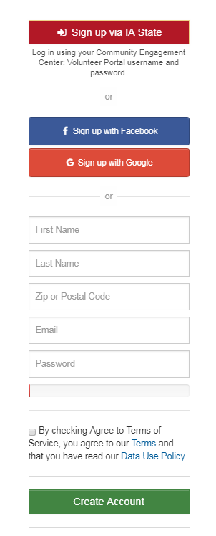
With this method, you can sign up and log in via Facebook, Google, or with a personal email address.
However, if you would like to use your ISU email address to log in, you must do so by clicking to sign up or
to log in.

Note: You will not be able to sign in with your ISU credentials if you do not log in through http://iastate.givepulse.com
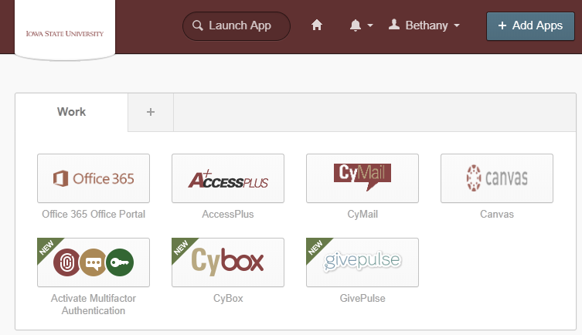
Hint: For ISU affiliates, GivePulse can be accessed via the ISU Okta page (http://iastate.okta.com). You can add GivePulse as an app to your quick sign-in page. If you are signed into Okta, you will automatically be signed in on GivePulse

If you have signed in successfully via http://iastate.givepulse.com for the first time, you will be redirected to your Dashboard. If you have signed up and logged in previously, you will be redirected to the ISU GivePulse homepage:

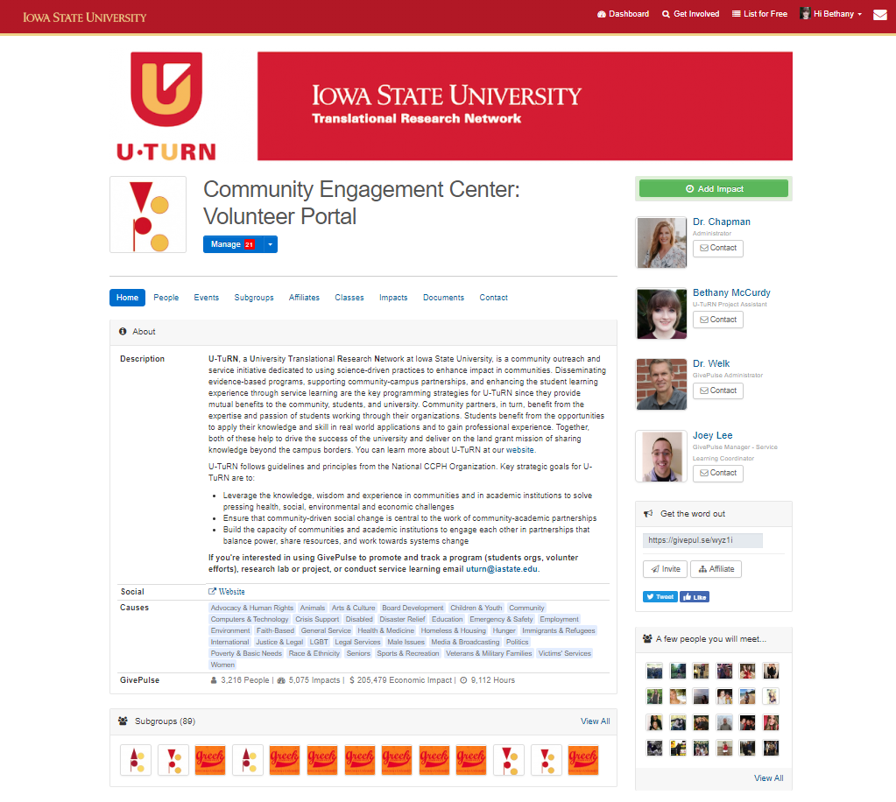

At any time, you can access your Dashboard by clicking on the icon at the top menu bar. You can access the ISU GivePulse homepage by clicking the logo in the top left corner of any page.

The dashboard is a great place to begin walking through GivePulse, as your dashboard is where you will find the tools you need to navigate throughout the site. This includes your groups, events, and impacts. Since your account is new, you will want to create a profile that best describes you and your interests. You can do this starting from your dashboard.

Creating your profile
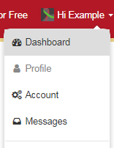
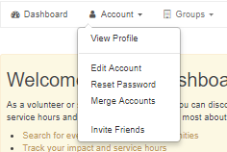
Before using GivePulse’s features, we recommend that you fill out your personal profile. You can access your personal profile via your dashboard or by clicking your name in the top menu bar to reveal a drop-down menu.

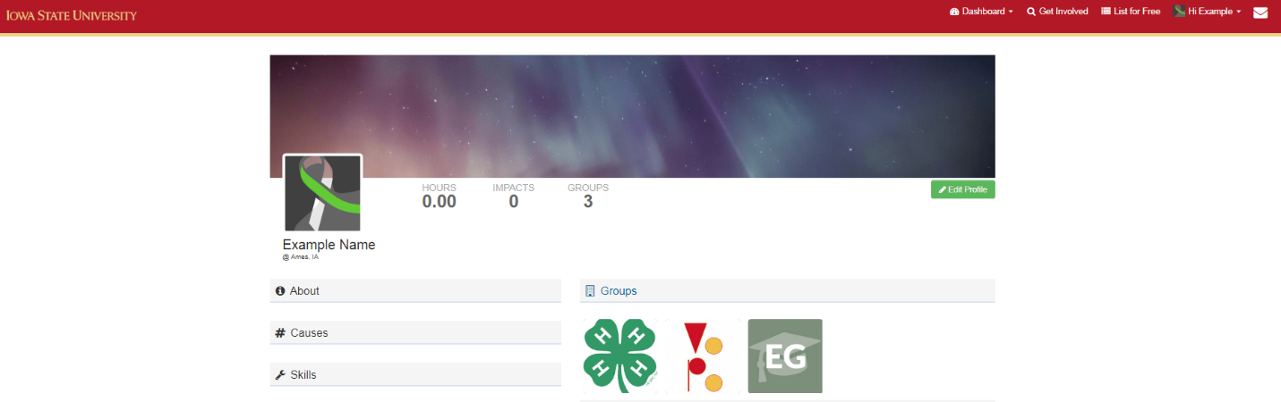
an example of what your profile might look like. note: if you are a first-time user, you will likely not be a member of any groups and see them on your Dashboard yet.
Your personal profile will highlight information you choose to share about yourself, as well as the groups you belong to and the impacts you have made. To edit your personal information, click the button. Here, you have the option of adding a profile photo (recommended), contact information, research interests, links to social media, and additional personal information. Since you are representing yourself to multiple organizations and members, we recommend that you fill in as much information as possible. This will help to better identify you, your organizations, and the causes you care about.

Now that you have created your profile, you are ready to begin using GivePulse! To help you become more familiar with GivePulse and the features that will be useful to you, the information provided below is based on how GivePulse may be used in different hypothetical situations. The various features of GivePulse will be described from the perspectives of community leaders/partners, teachers/researchers, and students/volunteers. The possibilities with GivePulse are truly unlimited; it is our hope that these examples simply highlight the system’s possibilities and help you understand how GivePulse may be used most effectively in your own work .
GivePulse for Community Leaders and Partners
Creating Groups
As a community leader or partner, you have the ability to organize volunteers/memberships, events, and impacts in one location. In this hypothetical scenario, you are a community organizer that is interested in creating a GivePulse page for your organization - the Iowa 4-H Foundation. The first step in this process is to create a Group for your organization. To begin, click on your dashboard (see page 5). From here, click on the Groups tab and select “Create New Group”
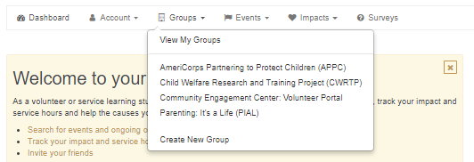
You will be redirected to a page where you will enter important information about your group, such as the group name, description, location, contact information, as well as the option to link your social media accounts: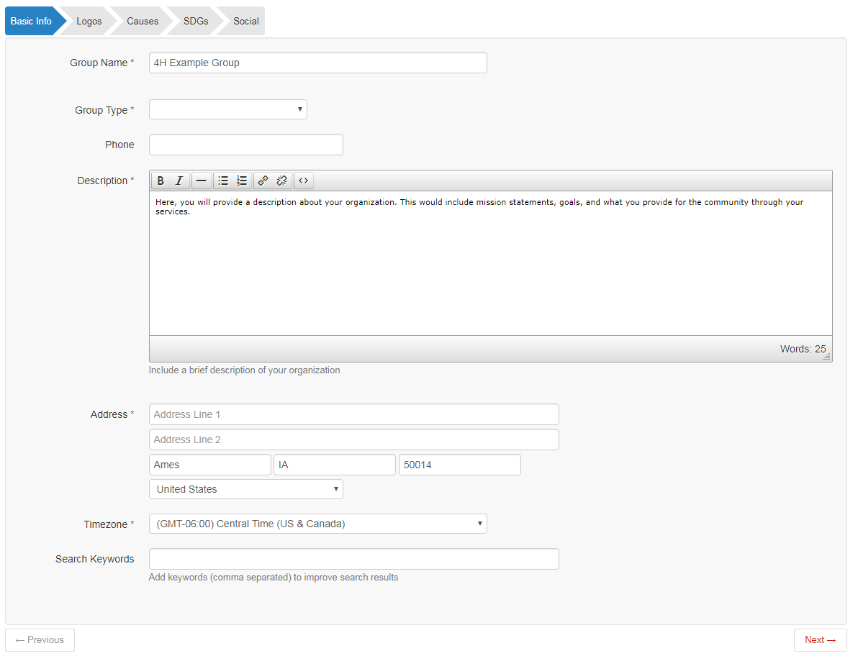
Upon successful creation of a group, your group’s main page should now look like this:
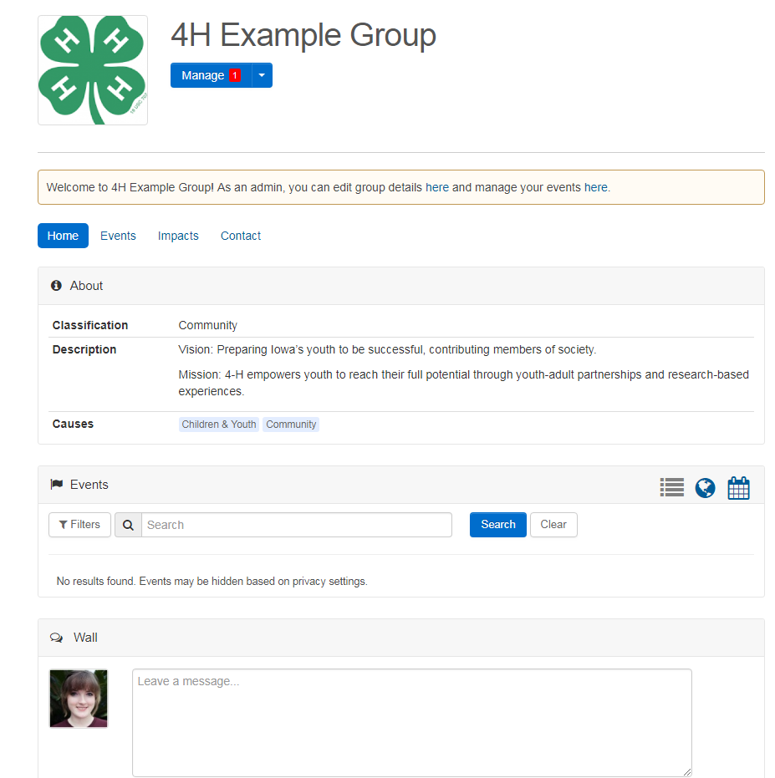

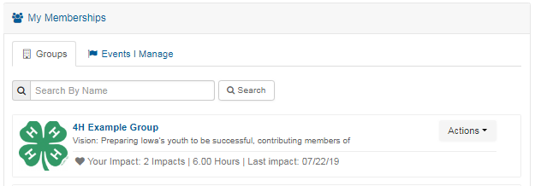
Hint: To access your group’s main page via your dashboard, you will now find it under My Memberships.

At the moment, it doesn’t look like much is going on. We will now describe what it looks like to add events to begin connecting with other people and organizations in your communities.

Events – Opportunities for volunteerism
It is time to create an event! As leaders in our hypothetical group, the 4-H Foundation, you and your colleagues are planning to host the annual youth county fair and need volunteers to set up informational and registration booths, gather donations, host games, and collect signatures for a lottery to win a free iPad.
To create an event, you will navigate from your group’s home page (see page 8 on how to access this), click on the blue arrow of the “Manage” drop-down menu, and select “Add Event”
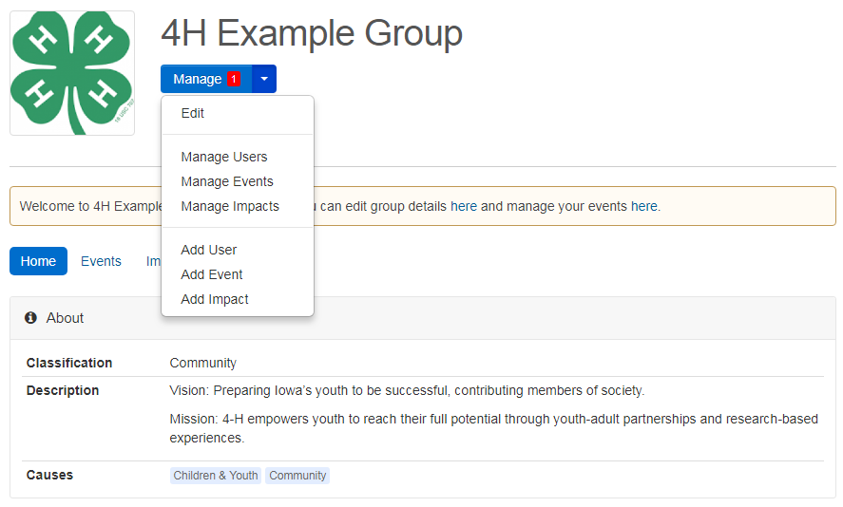

You will then be redirected to the following descriptor page, where you will enter important information about your event, such as the name, type (volunteer opportunity, ticketed event, fundraiser, or other type of event), location and time, desired participants/volunteers, and a description of your event and the type of help you are looking for:
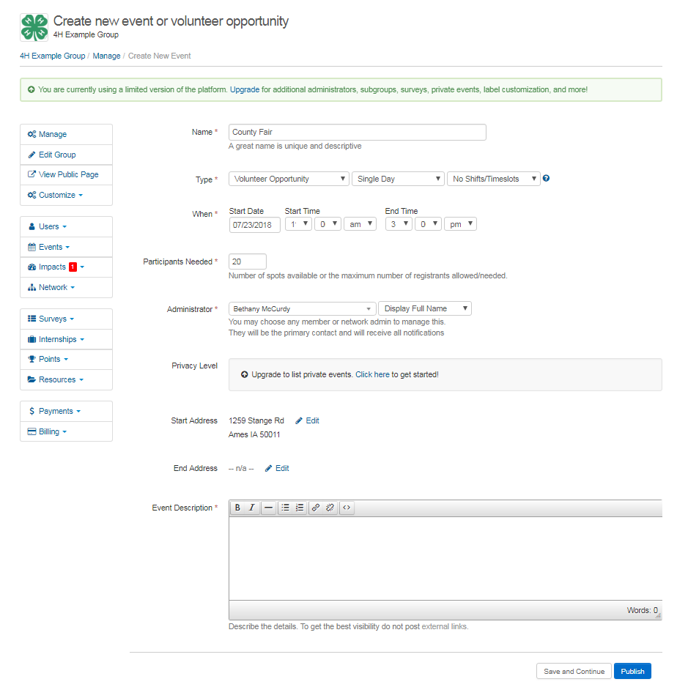

Making sure you fill this information accurately is important, as members and volunteers who are looking for volunteer opportunities on GivePulse will be able to search for specific types of events they are interested in!

Once you fill in the information, you can Publish your event to make it “go live” or select Save and Continue to add additional information. If you selected Save and Continue, you will arrive at the Edit Advanced page. On this page, you can access options to change Registration Settings (allow guests to register, waitlisting, group registration, etc.). These options will allow you to give permission to the general public to register for your events or to keep it strictly available to GivePulse members*. You can also set up Registration Questions to request specific information from your registrants. You have the option to save this page and come back to it later by clicking the “save” button. Don’t forget to publish your event once you are done! Once your event is published, it will appear in the search index and members of the 4-H Foundation will be notified via email.
Hint: If you are affiliated with another group, they will be notified of your event and can authorize your event to appear on their group page. (For example, since the 4-H Foundation is a subgroup of ISU, our County Fair event can appear on their group page. See the extended glossary for a more detailed description of “affiliations” on GivePulse and how they benefit you.)
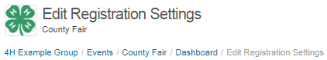
*As a general feature, anyone can register to participate or volunteer in an event. If someone wants to participate but does not have a GivePulse account, they will enter their first and last name as well as their email address when registering. When creating the event, administrators have the ability to filter registrants, meaning you can set it so only those who have a GivePulse account can register. You can also directly approve or set registration to “auto approve”. You will find these settings under “Edit Registration Settings”
Creating and tracking impacts
As we’ve learned, Events on GivePulse are a great way to organize participants and advertise events you host. Events not only benefit organizers, but also act as a great tracking system for your volunteers! Volunteers can search for and participate in Events, and once they are done, they will record hours worked or volunteered at an event and reflections or feedback of their experience through impacts. As an administrator, one great feature of GivePulse is the ability to track impacts, which are the footprints we leave behind through our community events. Administrators have the ability to track the impacts of volunteers and keep a record of hours each individual worked or volunteered, donations received, amount fundraised, and various goals within your group. Not only are impacts crucial for keeping a record of volunteer efforts, impacts are helpful in analyzing the reach of your organization in our communities.
To access volunteer impacts, return to your group dashboard and select “impacts” from the toolbar. 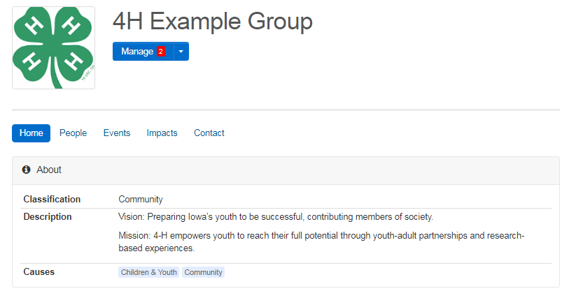
If we choose to “View Impacts”, we will not see any because no impacts have been created yet through our hypothetical group, the 4-H Foundation. To see how you can enter one for a user, on the same page, we will click “Manage” > “Add Impact”
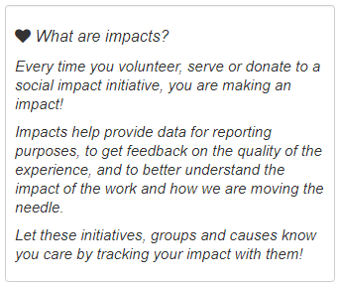
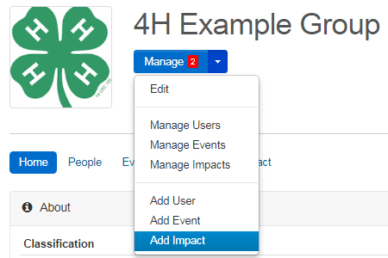

After clicking “Add Impact”, you will be redirected to the following page:
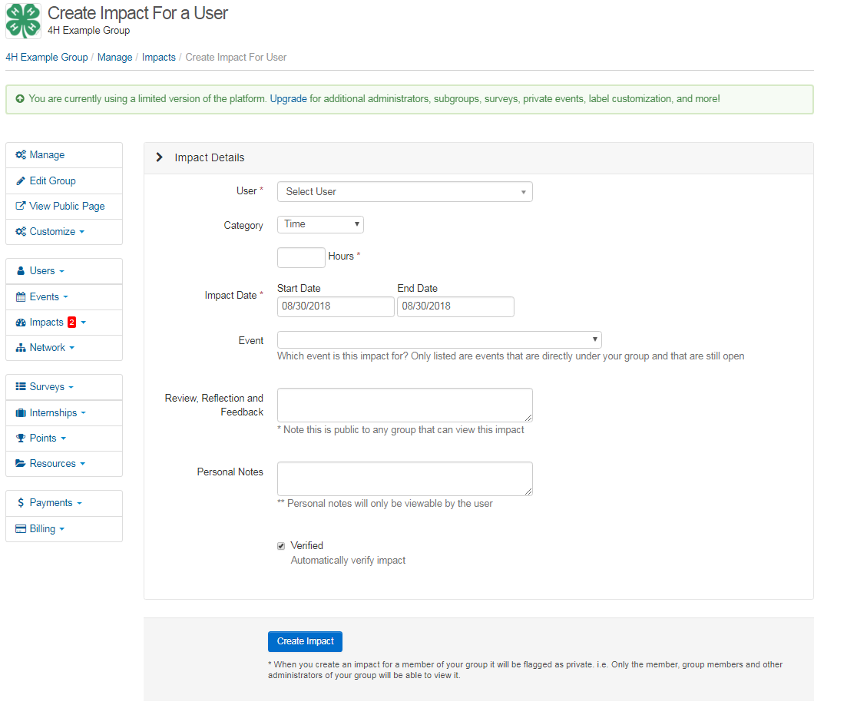

On this page, you will add information about the event where the impact took place, as well as what activity you are considering to be the impact. Since you are entering an impact for the user, you have the ability to automatically verify the impact as you create it!

Remember to encourage members of your group or volunteers to keep track of the date and hours worked/volunteered, as this will be important for tracking not only their hours but the influence of your organization within the community! If a student or volunteer has registered for an event that has a specific date and time, an impact is auto-generated- they will receive an email after the event is over to review the impact and submit it. To remind a member or volunteer to enter an impact that may need manual entry (for example, a volunteer had to leave early so they did not fulfill the total amount of hours originally registered to serve), you can message them directly through GivePulse. Messages sent through GivePulse will also appear in the inbox of the email they used to sign up (or, in the case of non-members who registered for an event, it will appear in the email they used to register for the event). In the case that a member who registered for the event cannot log their impact and is not a member of a group (i.e. someone who registered for an event without group membership), you can manually do it for them. All of these options are conveniently available for you on the Manage Users page of your Event (accessible by clicking Users > Manage Users on the right-hand side of the Event page).
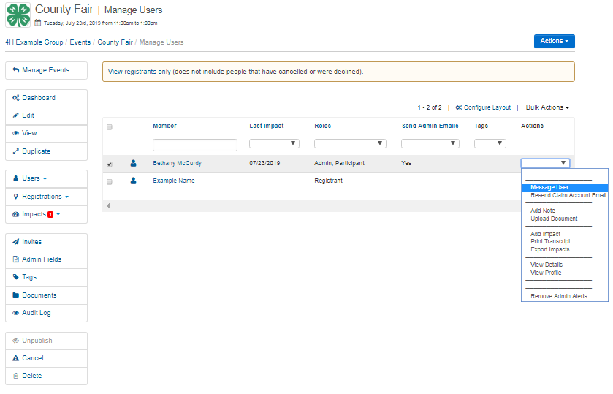

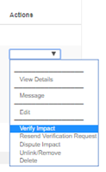
When your members/volunteers submit impacts, you will need to verify their impacts. To do this, go to the 4-H Foundation homepage (see page 8) and click the button. On the left-hand menu, select and then . Each members’ impacts will show. To verify, go to a specific user’s name and verify their impact via the drop-down menu under the Actions column. Verifying impacts is a highly important feature accessible only to administrators. Through verifying, you can make sure there are no duplicates and ensure fidelity of tracking hours. Hours recorded will not count unless they are verified by an administrator.

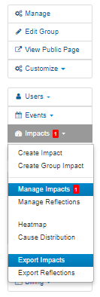
Depending on your interests, you may want to download the data generated by members entering in their impacts. To download data from impacts and transfer them to an excel file, you have two options: “export impacts” and “export reflections”. Both options will create an excel file for you with all of the important information concerning the user and their impact. To access this, click Impacts in the left-hand menu of your group page and choose your option from the bottom of the drop-down menu.

Hint: You may notice from this menu that you can create a Group Impact. Group Impacts are similar to individual impacts and work in the same way but represent the group as a whole. One example of a Group Impact relevant to the 4-H Foundation might be “Raised a total of $500 during the fundraiser”.
Managing members and volunteers
As a community leader, you will have the option to have administrative oversight for your organization members and volunteers. While individuals have the option of becoming a member of a group by clicking on the group page, you can add members directly. If for any reason you wish to remove members from a group (i.e. inactivity), this option is also available.
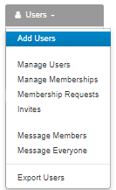
To add a user, click on Users > Add Users. Fill in the fields with the users’ name, roles, and email. Users will receive an email by default and a link to claim their GivePulse account if they have not created one. If you want to add multiple members at once, you have the option to upload a csv file (see the option in the top right corner of the Add Users page).

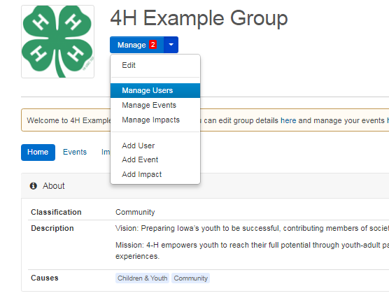
To find the Manage Users page, return to the group homepage (see page 8), click on the arrow of the blue button, and select “Manage Users”.

On the left-hand menu, select “Users” and you will have multiple options- you can change User Roles (member, administrator, etc.), track total number of hours and impacts, add notes, and various other actions. You can change what you see on this page and how you choose to organize your members and volunteers by clicking on Configure Layout.
GivePulse for Teaching and Research

As a teacher or researcher, you may want to organize a class where you can track lab meetings, reports, student efforts, class documents, or have an online portal that links to a class you are teaching at a university or in the community. Classes on GivePulse differ from Groups in that they are designed to accommodate multiple types of classes, such as classes with Deliverables, Placement classes, and/or classes with Engaged Research. Deliverables are the end product of the class, which includes projects, presentations or something like a final reflection essay. Placement classes are designed to immerse the student and place them with a community partner as a requirement (some institutions have required n number of hours for certain placements), and Engaged Research classes work with faculty, staff and/or empower a student to apply current research to address community issues and disparities. The type of class you want to create isn’t limited to these styles- how you want to design your course is entirely up to you and your needs.

In this tutorial, we will create a class that encourages students to use GivePulse to search for volunteer events and to track their hours to be verified by the class instructor. For our example, we are going to create a class that reflects a hypothetical course being offered on-campus - the class will reflect a Kinesiology course titled KIN 000 (for clarity, the name of the class on GivePulse will be titled KIN 000-GP). The goal of this course is to have all the Kinesiology students enrolled in KIN 000 volunteer at a total of 3 events in the community, with a minimum of 2 hours volunteered at each event. The instructor of the course will have a way to verify and document the hours of each student and students will be able to search for volunteer opportunities through GivePulse and record their volunteer hours directly to the class under KIN 000-GP.

Creating a class
To create a class, you will do so from the main group page- Community Engagement Center: Volunteer Portal. Since you have administrator privileges, you will see a blue button on the main page. Clicking this will bring you to the group management page. On the left-hand menu, select “Academia” > “Create Class”

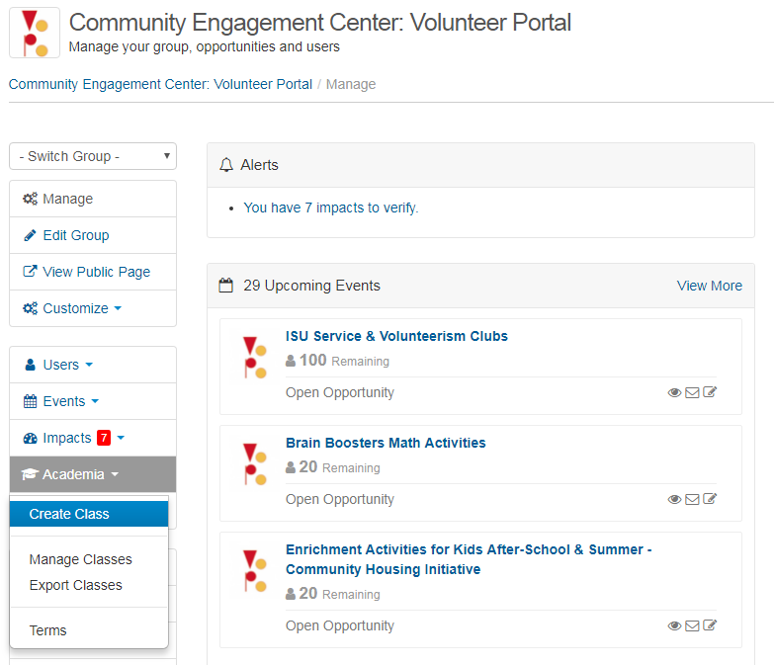

On the following page, you will enter in information about your new GivePulse class. Enter in all the relevant information (we recommend entering in as much information as you can):
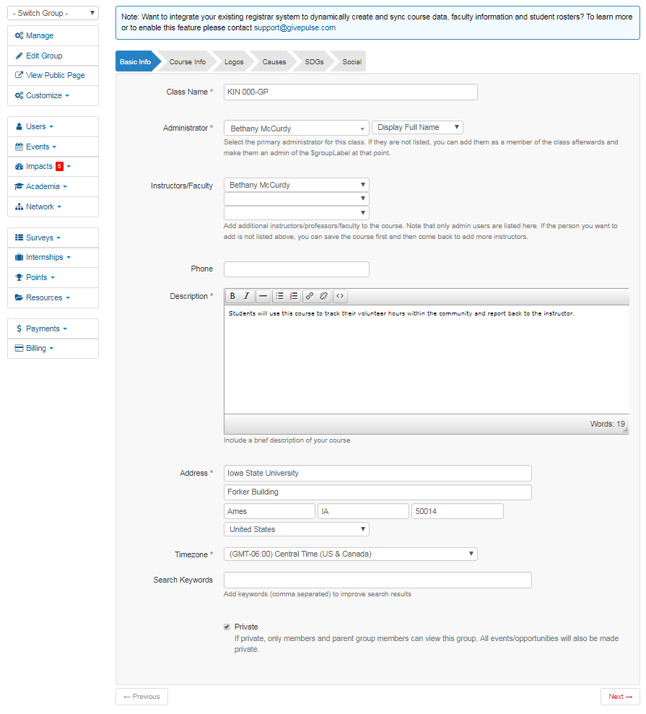
Hint: You will be able to access your new class via your personal Dashboard under “My Memberships”!

To view a short video on how to create a class and affiliate it with community partners, follow this link: https://vimeo.com/169401510

Managing members and impacts
Once you have successfully created the class, you will be redirected to your class home page.
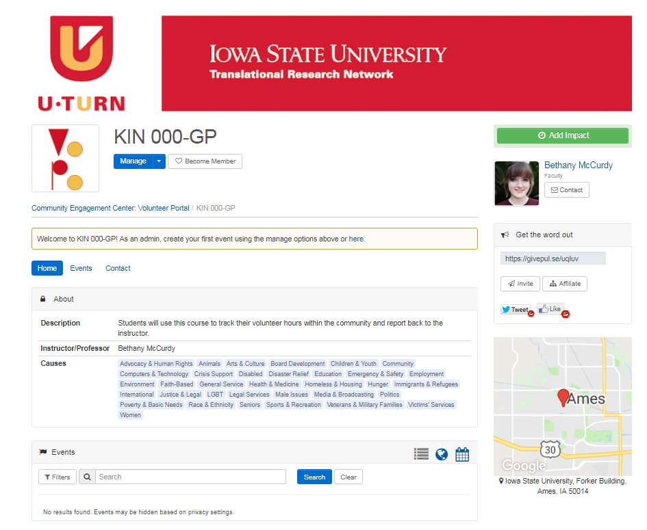
Next, we will begin adding our students to the class. Click the blue “Manage” button and select “Add User”
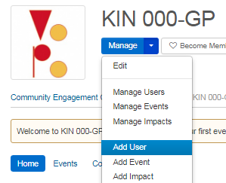
You can add users individually or in bulk by selecting the option in the top right corner. We will add a student to the class and see how their “impacts” are reflected within the class and how you can download the data generated by impacts for your needs.

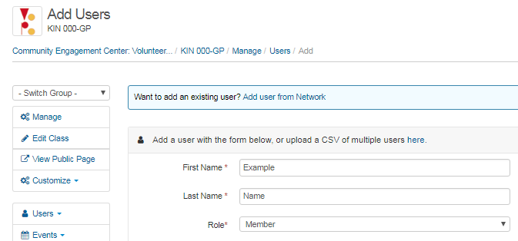

Our new class member, “Example Name”, has just volunteered for 2 hours at an event in the community and recorded their impact in conjunction with the class. Because these steps were taken, the volunteer hours appear both under the original Event page and your class page. To do this, they selected “KIN 000-GP” as they were creating their impact to allow sharing of their logged impact between both groups.

Once impacts are shared with the class, you will need to verify them. To access impacts that your students have uploaded, navigate to the home page for the class and select the blue “Manage” button followed by “Manage Impacts”. Here, you can view individual impacts and verify them by selecting Verify Impact under the Actions column.
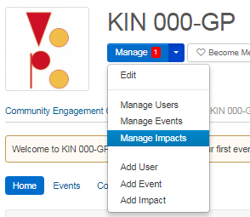
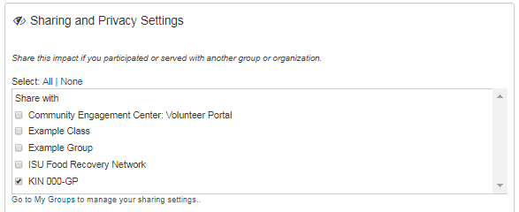
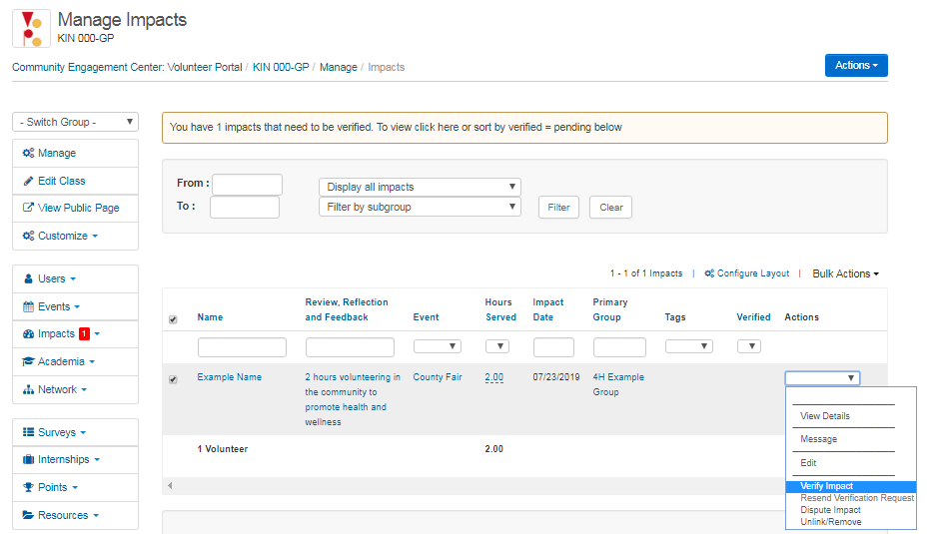
This impact now appears both under the primary group where it was submitted and within your class! Any member of the class can see the impacts by going to the class home page and selecting “Impacts” from the toolbar.
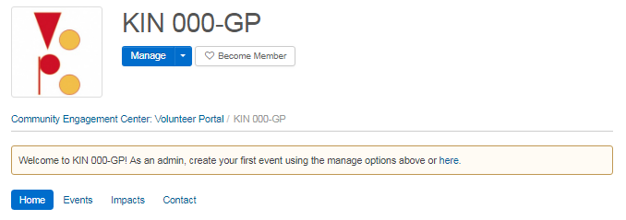

Let’s say it is the end of the semester and all of your students have uploaded or shared their impacts to the class. You want to see where students were volunteering the most, how many total hours were volunteered, and the feedback provided by each student. GivePulse automatically generates all the information about impacts in an excel file that will allow for easy documentation! To access this excel file, you will need to export the impacts. Return to the class management page by clicking the blue “Manage” button on the home page, select “Impacts” from the left-hand menu, followed by “Export Impacts”.
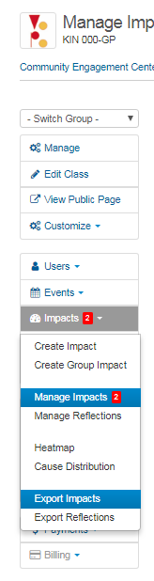
This will automatically generate an excel file
that exports all the data recorded within each impact:

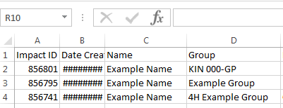

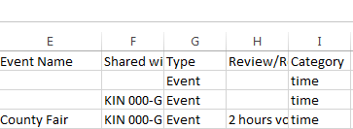
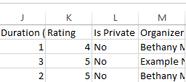
Events – opportunities for research
Similar to the way Events are created under Groups for opportunities to volunteer within the community, teachers and researchers can create events that tie in with class activities. Some examples of these types of events are meetings, conferences, and training opportunities. For example, if you are a researcher who wants to organize groups to meet weekly for a class project as part of a “lab time” component of the class, you can do so by creating an “Event” for the lab meeting within the GivePulse class. We will explore this by creating a recurring lab meeting under our example class, KIN 000-GP.
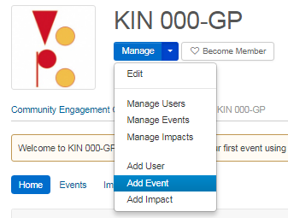
To create an event for your class, click the blue “Manage” button followed by “Add Event” on the main page for your class. This will bring you to the “Create New Event” page, where you can fill out information about your new Event. In this example, we want to create an event for a lab meeting that occurs every Monday from 1:00 PM to 2:00 PM for the next 20 weeks. We expect no more than 7 students to show at each meeting. We will fill out the page as follows to fit our lab meeting schedule:

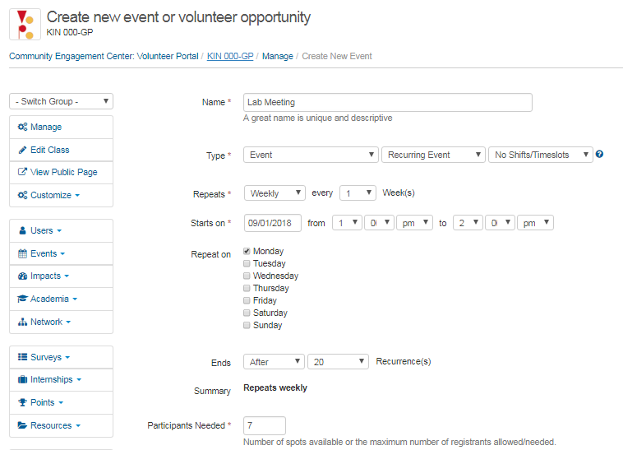
Now, you need to students to fill in those slots! You can request they search for the Lab Meeting event itself within the Class page and clicking the 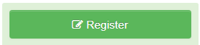 button or you can invite them through GivePulse. After you publish your new Event, you can invite members by going to the Class home page, clicking “Events” in the toolbar, selecting your new Lab Meeting event. On the right-hand side of the page, there will be an “Admin Panel”- click on “Dashboard” to arrive at the Lab Meeting dashboard page where you can invite members via clicking “Invite people to participate”:

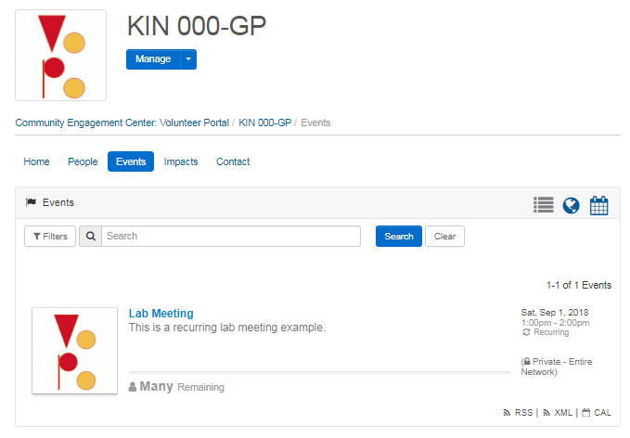
How to invite members to Events within a class
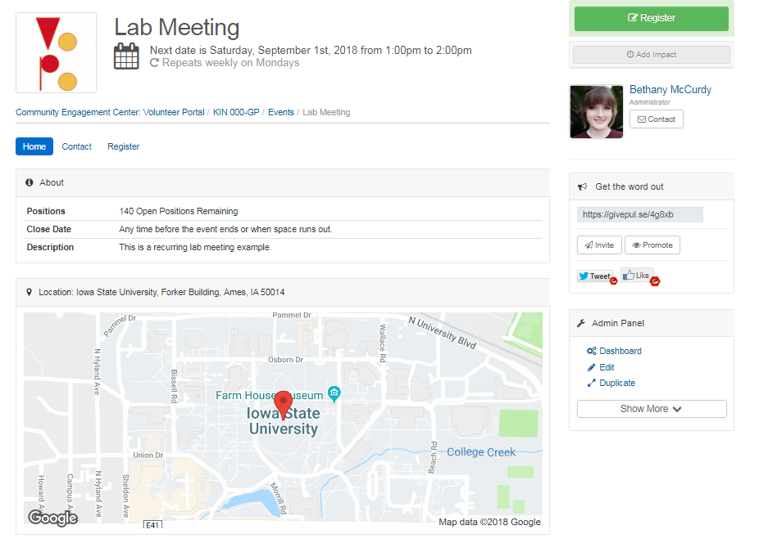
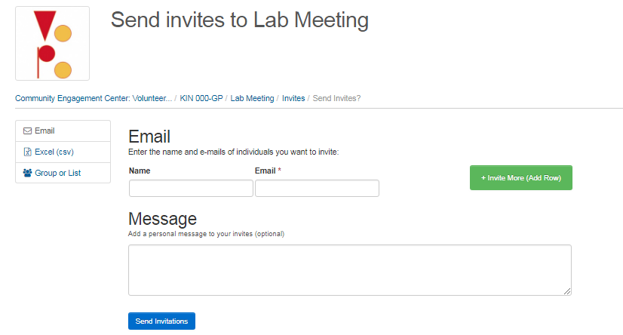
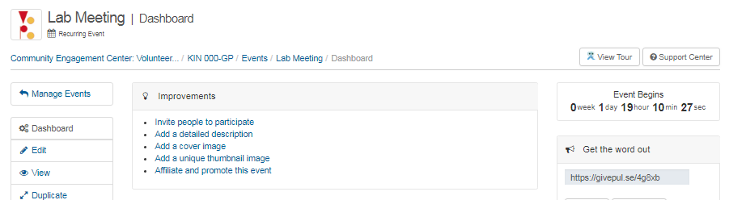
Breakdown of Service Learning Features
GivePulse acts as a service learning platform. There are 6 features of service learning that GivePulse provides, broken down into sections below: Course Management, Applications, Community Partners Database, Placements & Scheduling, Assessment, and Verification.

Course Management
With course management, you can synchronize your course details and rosters to promote faculty, staff, partner, and student academic engagement. You can define course requirements and select which partnerships, events, and opportunities you would like to display in the class. Most importantly, you can determine the quantitative and qualitative outputs (hours, reflections, etc.) needed to gauge student learning outcomes and run reports on academic progress and achievement.

Applications
You can manage, create, edit, approve and review all partner applications and student-to-partner applications. You can also set up Memorandum of Understanding (MOU) documents and create a unique application to gather details of the potential partnership for you, your partner, and a collection of individuals to review and approve. You can also set up an MOU between the student, the partner, and yourself, in which all three stakeholders can pass the MOU to the other(s) for further review, editing, and acceptance.

Community Partners Database
The community partners database is an all-in-one solution that allows you and your partners to have complete access to oversee profiles, match interests, activities, events, and opportunities with students, faculty, staff, researchers, and alumni! You can search and interact with partner profiles - partners you connect with can share their updates, social media, contact information, and create new events and opportunities available to you and your community of users (students, etc.)

Placements & Scheduling
You have full oversight on scheduling for individuals and groups while enabling organizers to know exactly the status of all student placements by attendance, hours, reflections, or other outputs you define. You can set up orientation dates, one-time events, or ongoing opportunities in a calendar, map, or list. With the calendar feature, your community of users can view events, training, opportunities and activities that they can register for or use to track their engagement.

Assessment
Survey, track, and review all data related to student learning and impact in your local community. You can send unique surveys anonymously or via a login for small groups of students, the whole institution, or specific partners. Customize and design these surveys with quantitative and qualitative fields so you can accurately collect the data for the assessment of your community impact. You will have a single place to gather all the data collected so you can review and report on specific users, activities, groups, and partners.

Verification
Need to track hours of students? Have a “clock in” and “clock out” system? You can do this with GivePulse’s attendance features! Service hours are the most popular output gathered by GivePulse’s system, but this ability extends to what you define as metrics important to your institution, the community, or the student’s engagement. Additionally, impact reflections allow faculty, students, and partners to have a dialogue. This allows the conversation to continue past the experience, past the class, and into the future.

GivePulse for Students and Volunteers

Whether you’re a student at a university or a volunteer looking to serve the community, GivePulse is a tool that will help you keep track of your efforts and provide opportunities to engage with teachers, researchers, community partners, and other students and volunteers like you!

One great way to describe GivePulse is like a social media platform. You will find yourself interacting within the ISU network - this includes participating in groups, classes, and Events that are hosted by the university or our community partners. You can use GivePulse to browse and search for groups and events you are interested in and register for these events. GivePulse allows you to log your research and/or volunteer hours and experiences to document all the impacts you’ve made, which is a great feature that will help you and your partners know the footprints you leave behind as an individual and as part of a group. You can even use the messaging system within a group by writing on the group wall or message privately on your personal account to other members of GivePulse (this way, it is much easier to communicate with other students, volunteers, community leaders and/or partners and keep track of everything in one place).

Much like we’ve done in previous sections of this tutorial, we will use examples from the hypothetical scenario of volunteering for the Iowa 4-H Foundation group.

Joining a Group
Becoming a member of a group is a good way to be a part of a movement or cause that you care about. Before you ever made your account, you may have had an idea in mind about joining a group you were interested in. Joining a group is useful for both volunteers and students who want to engage with the community to apply knowledge in real-world applications and gain professional or volunteer experience. Joining a group means having access to the group’s updates on events, partners, classes, impacts, documents, and much more! In this part of the tutorial, we will discuss how to search for a group, how to join one, and how to use the group page to your benefit.

Hint: If you are a student, you may want to join a group that houses a class you are enrolling in. Classes are an important feature of GivePulse, so we will discuss how to join one on pg. 32.

To join a group, locate the menu at the top of screen and click “Get Involved.” This will bring you to a search engine where you can browse through the list of groups that are within and close to your zip code. If you know the name of the group you want to join, you can type it in the search bar at the top of the page. For this tutorial, we are interested in joining the ISU 4-H Foundation, so we will search for it here under the “Groups and Organizations” tab.

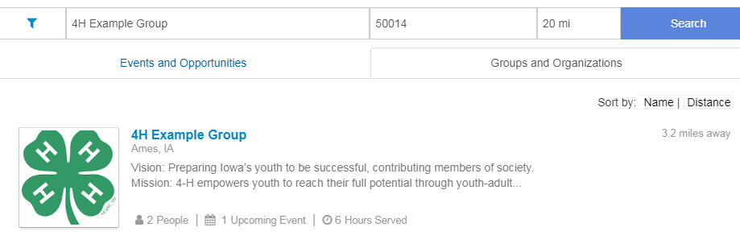
Once you find the group you want, click on the name. You will then be redirected to the Group page and should look similar to this:
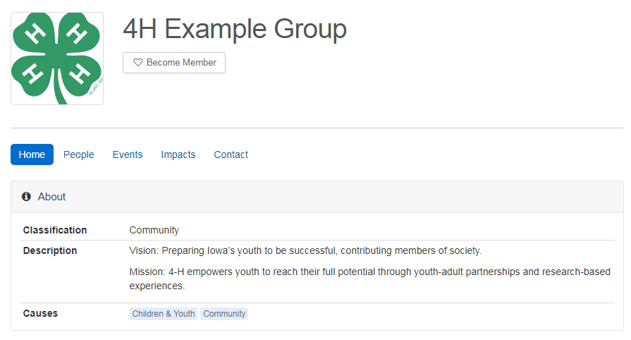
To become a member of this group, simply click “Become Member” below the group name. When becoming a member, depending on the membership requirements set, you may join immediately or be prompted to fill out an application that would require you to wait for approval by the administrator or organizer of the group.

Once you have been verified, you are officially a member of the group! This means that you have access to special events that would otherwise be blocked or invisible to the general population. Being a member also makes it much easier to follow updates from your group, as a shortcut to the group page will now appear on your personal dashboard under “My Memberships” (see hint on pg. 8).

Here, you can access a list of members who are also a part of this group under the tab “People”. If you want to view a list of all the events related to or created by this group, you will find them under the “Events” tab. The “Impacts” tab shows you a list of all the impacts entered by members of the group.

Now that you have become a member and received access to this group’s events, it’s time to register for one! The next section will walk you through searching and registering for events.
Events – Opportunities for community engagement
Searching for events to participate in is easy, as there are multiple ways to search for them! If you are a member of a group, you will have access to that group’s events on their Group dashboard. All the events hosted by your group will be visible under the section labeled “Events”:
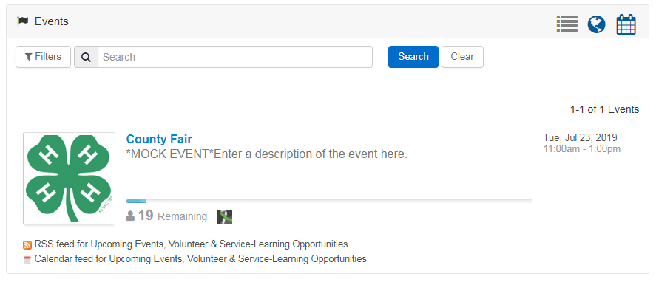
Here, we see that the ISU 4-H Foundation is hosting an event named County Fair.
If you are looking for events to register for that are not hosted by any group you are a member of, one way you can search for them is by clicking on the menu bar and searching through the events and opportunities tab:
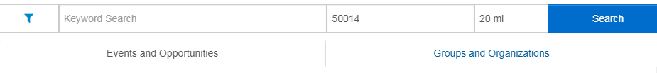
To register for an event, click on the event name where you will be brought to the Event page. The event page will look like this:
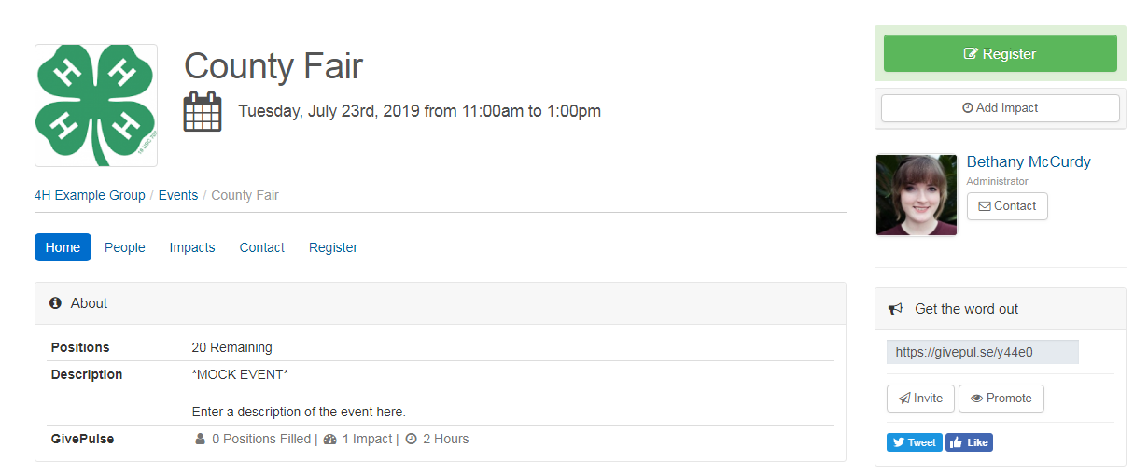
On this page, you can access a list of people involved, the impacts created within this event (which we will cover at the end of this section), contact information, a link to share the event, and an option to register. Click on the button to begin the registration process.
Depending on the settings put in place by the administrator, registering can differ in how it looks between groups. For example, the County Fair has a minimal amount of restriction s- all you need to register is your account (non-members of GivePulse cannot register for this event) and an agreement to the Platform Liability Release Form:
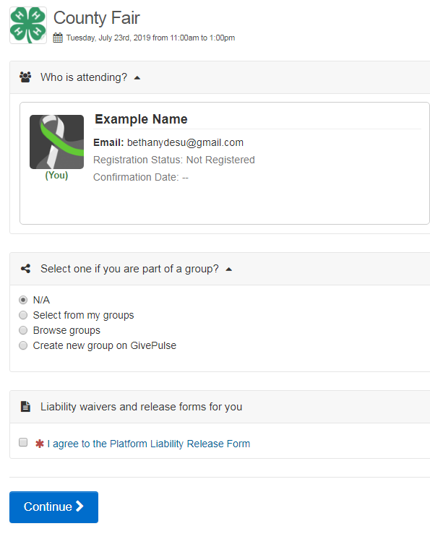
Some events have more information you need to fill out when registering or certain restrictions. For example, if we wished to register for an event coming up that has tighter restrictions, we will find that it is locked and requires a special registration code to sign up:
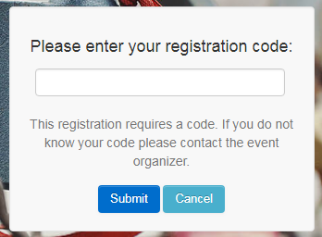
If we look at a different event, we’ll find this one is set up in a way where you select the dates you want to volunteer, followed by a request to fill out questions and waivers that are set up by the creator of the event:
If you run into any issues with registering for an event, be sure to contact the event organizer, who can help you with the registration process.
To view all of the events you have registered for, you will find them by clicking the icon and scrolling down to “My Registrations”
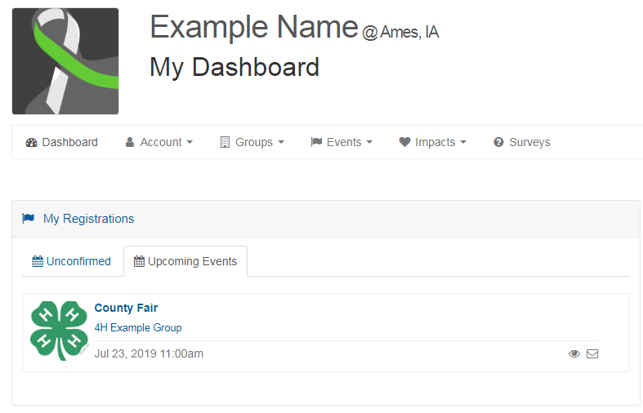
If for any reason you need to cancel your registration, click the “Update Registration” button on the Event page and then select “Cancel All”
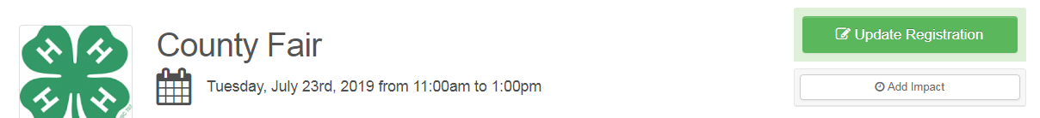
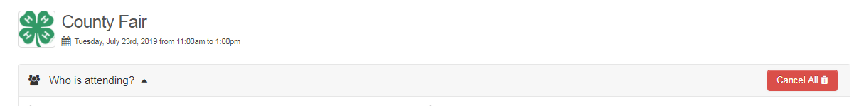
Don’t forget to cancel your registration to the event if you cannot make it - this will help the event organizer know who is available and how many people will arrive. If there are limited spaces for an event, your cancellation will open up a slot for a volunteer who can attend.

Joining a Class
If you are a student, you may be interested in joining a class for Service Learning, Experiential Learning, Community Based Learning, or Community Based Research. Classes serve multiple functions depending on what the administrator of the class wants - it could be a class that provides Deliverables (the end product of the class, includes projects, presentations or something like a final reflection essay), Placement (which immerses the student and places them with a community partner as a requirement, as some institutions have required n number of hours for the placement), or Engaged Research (work with faculty, staff or be empowered as a student to apply current research to address community issues and disparities).
It is likely that you already have an idea of a class you want to join that is administered by a professor who uses GivePulse. In some situations, your professor may have already added you to a class on GivePulse. In other situations, you may be requested to find and enroll in the class on your own. For Iowa State University, all classes can be found via the main group - Community Engagement Center: Volunteer Portal. You can find this page by clicking the logo in the top left of the page or by following this link: https://iastate.givepulse.com/group/5616-Community-Engagement-Center-Volunteer-Portal
Once you are on the main group page, find and click on the Classes tab in the group menu:
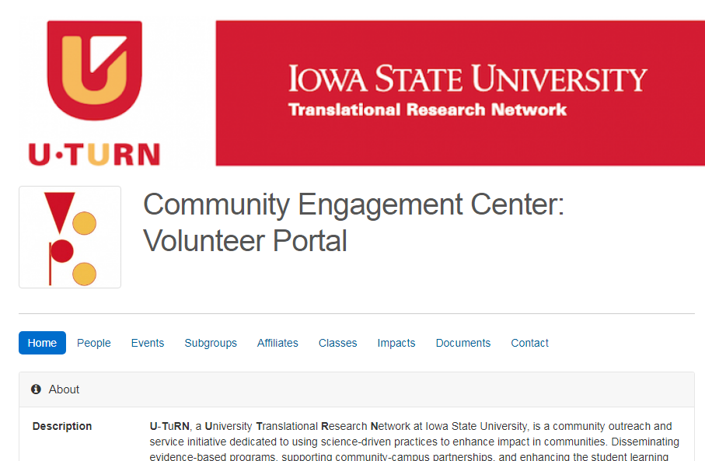
On this page, you can search for a class in the toolbar or scroll through the list of available classes.
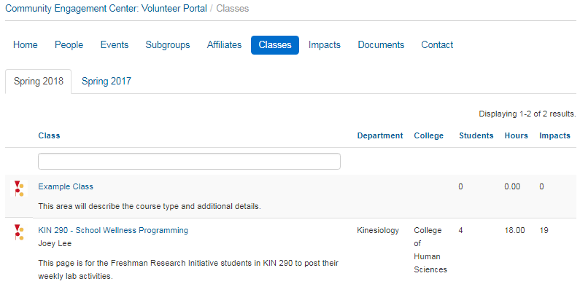
Let’s say we’re a student and we want to join a class on GivePulse as requested by a professor. The professor wants to use GivePulse as a means of tracking progress within the lab on various projects. To join the class, we will click on “Example Class”. Classes work similarly to Groups (in fact, they aren’t much different at all - a class works in a lot of the same ways as a group, as we’ll see below). To join the class, click on “Become Member” below the class name.
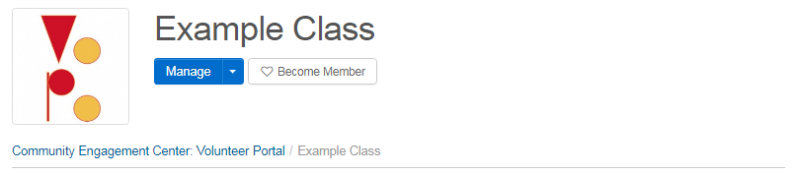
Based on the privacy settings of the class you are trying to join, you may have to request to join:
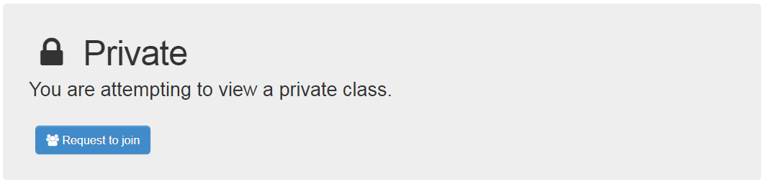
You may be able to join a private class immediately or you may need to wait for administrator approval. After you have been approved and become a member, you can join events set up by the class!

Events – Opportunities for research
On this page, we see an event we’re interested in titled “Lab Meeting”:
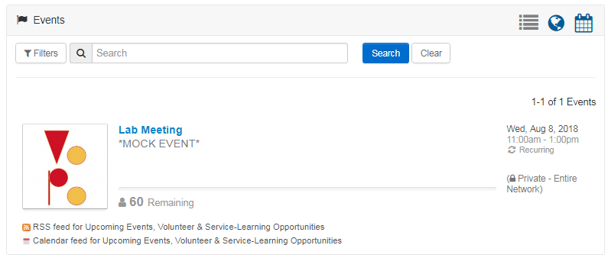If we look at the details on the right side of the name, we can see it is a recurring weekly event within a certain time frame (in this case, 11am-1pm every Wednesday). Let’s go ahead and let our professor know that we will be attending the weekly lab meetings. Like other events, click on the name and select the option. The page that follows will look differently for each class. In our case, we will select the dates we are attending.
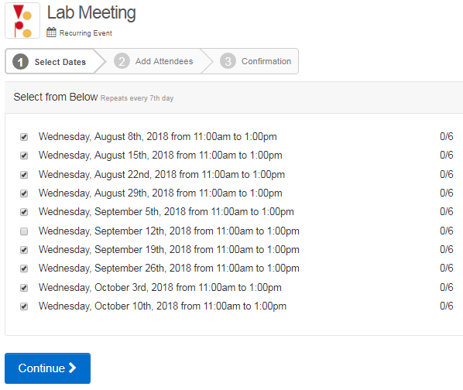
The 0/6 to the right of the dates lets us know how many positions are still available. We can see here that our professor expects 6 students to attend each lab meeting. We did not check the box for Wednesday, September 12th, as we are expecting to be out of town that day. This is a great way of letting your professor know your availability and to have the scheduling all in one place.
If your availability changes, you can edit the dates you can attend by clicking the 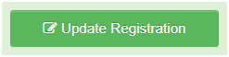 button on the Lab Meeting event page. You can find reminders for the dates you plan on attending at the bottom of the Lab Meeting page.
In the next section, we will learn about impacts that relate to Events (like lab meetings) within classes.
Impacts
Every time you volunteer, serve, or donate to an event, you are making an impact! Impacts reflect individual and group efforts, to express quality of an experience via user report, and to better understand the reach of work happening in the university and in the community. Impacts can range from any direct interaction between you and organizations, you and events, or can be individual or smaller group achievements, like doing research, setting up office hours, having a meeting, training yourself or others, handing out marketing materials, etc. Impacts are a great way to log all the activities that happen individually or within a group. Different groups may report different types of impacts. One example of an impact that students log, for instance, may be research hours, such as logging progress on writing papers, doing literature reviews, interviews, and general meetings with collaborative partners in research projects. For volunteers, impacts may reflect activities accomplished at events, such as setting up tables, handing out flyers, and providing services.
In this part of the tutorial, we will first walk through what entering an impact for an event related to a group looks like for a volunteer, followed by entering an impact for an event related to a class for a student.
Volunteers
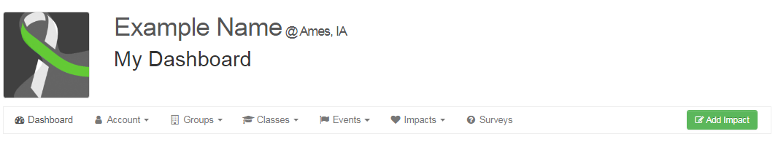
In this scenario, you have just wrapped up volunteering at the County Fair, where you operated the sign-up table for people who want to learn more about the ISU 4-H Foundation. You want to report back to the group to let them know how many hours you worked, what your experience was like, as well as upload a scan of the filled sign-up sheet.
Click on the icon at the top menu, where you will be directed to your dashboard and find a green 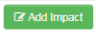button on the right side of the page:
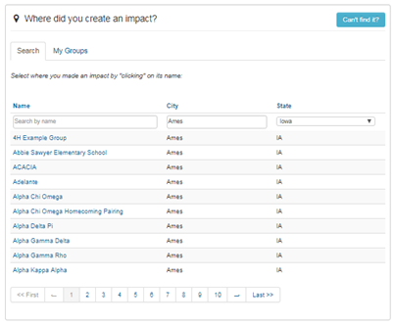

Here, you will type in the name of the group where you performed the impact.

Click on the group name and on the next page add information about the event such as where the impact took place, as well as what activity you are considering to be your impact. For this example, we are going to enter information about “working the sign-in table” as our impact.
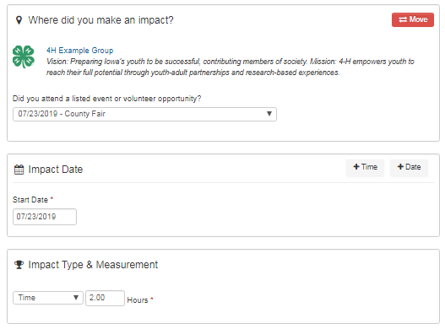
Above, we stated the Event where we performed the impact, as well as the date and impact type - in this case, a total working time of 2 hours. Impact types range from hours worked to money raised (or whatever you would consider an impact!) If your impact type is not listed in the drop-down menu, select “other” and give a description of your efforts.
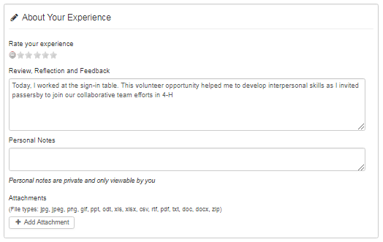
In this area, we describe our experience and give a reflection or feedback about the impact. This is useful for volunteers to detail your experience and to leave comments or personal notes. If you took photos at an event or scanned a sign-in sheet, you can upload that file here under “Attachments.”
Students
Adding impacts for research, teaching, training, or anything related to your university and coursework is very similar to how volunteers add impacts for community service. In this scenario, you want to add the impact of “training new lab mates” as part of your assignment given to you by a professor during a lab meeting.
Via your dashboard, find your class under “My Memberships” to go to the class page.
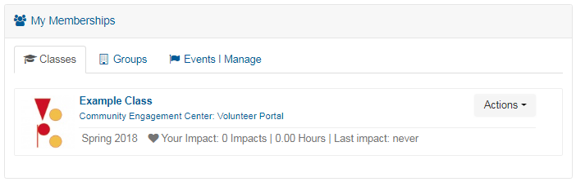
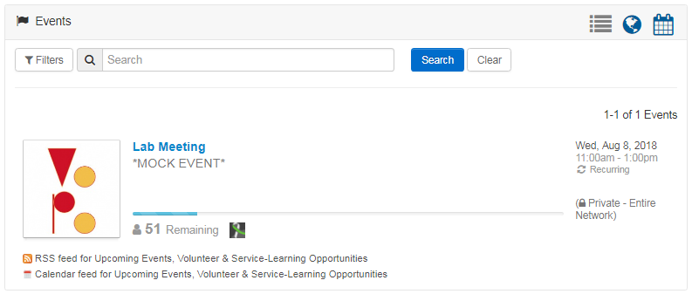

From your Event “Lab Meeting,” click the Add Impact button on the right side of the page. Here, you will add information about the event. There are multiple ways in which we can approach selecting the date related to the Lab Meeting for this event. For now, we will select the Lab Meeting date that you were given the assignment of training, which in our case will be October 10th. Under “Impact Date”, we will click on thebutton so there is only one date we will log our training.
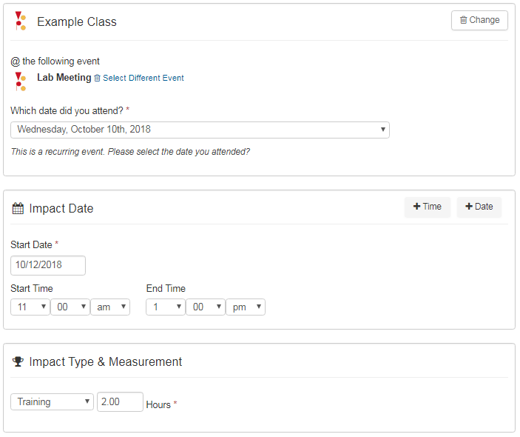

Further down on the page, we can report our experiences as well as leave feedback. Note that whatever you type in the “Review, Reflection and Feedback” box will be visible to everyone that is a member of the class. If you participated with another group or organization for your impact, you can choose it here. For example, if you are enrolled in a class that requires you to log your volunteer hours with other groups as a course requirement, you will be able to select the appropriate class or Group you intend to share impact information with under “Sharing and Privacy Settings” (see pg. 20 for an example). In this case, we are uploading our impact directly to the class, so we will not make any selections. You also have the option to upload any attachments here. If you made a training manual, this will be an ideal place to upload it! Note that attachments to impacts will also be viewable by anyone who is a member of the class.
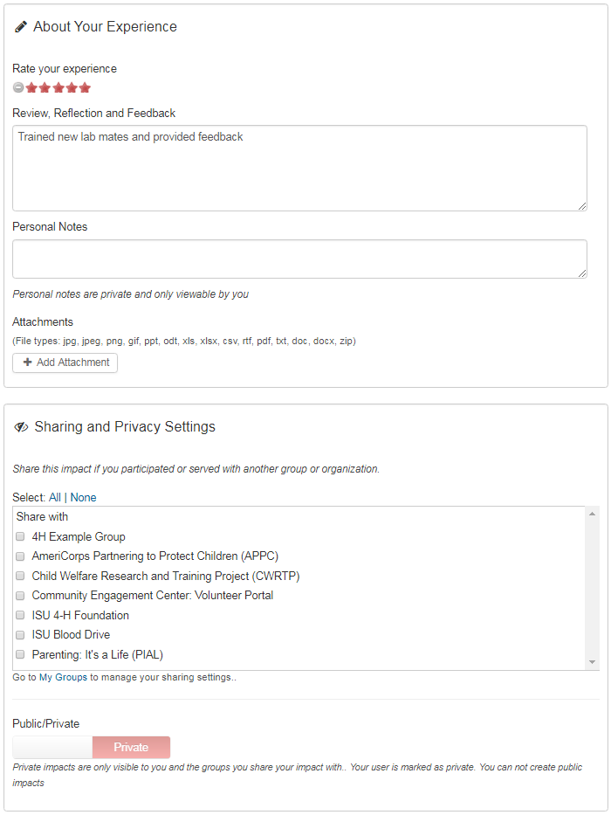

If you want to view all your impacts, return to your dashboard and click “Impacts” from the menu bar below your name and photo. Note that administrators will need to verify all impacts you submit.
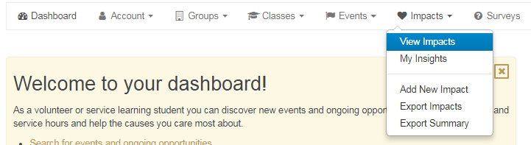
Extended Glossary
Affiliates - An affiliation is when one group displays all of their events on another group's page. For example, if you are a school and you want local non-profits to list all of their events on your page so that your students can find verified service/volunteer opportunities, you can request that they be affiliates of your school. This is a great way to build a community between your organization and other local organizations.
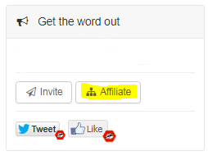
Affiliates are partnerships including nonprofits (501c(3)), businesses, and groups of all types that have programs and initiatives to address social issues impacting any given community. Affiliates can be any organization outside yours that you partner with to create a positive impact in the community (for example, the local thrift store where donations are collected).
One quick way of adding a group as an affiliate is to navigate to their Group page, locating the box on the right-hand side of the page titled “Get the Word Out”, and clicking the “Affiliate” button.
Additionally, you can add or create an affiliation with a group you manage by navigating to the group management page and clicking on "Network" -> Manage Affiliations -> Actions -> Create Affiliation.
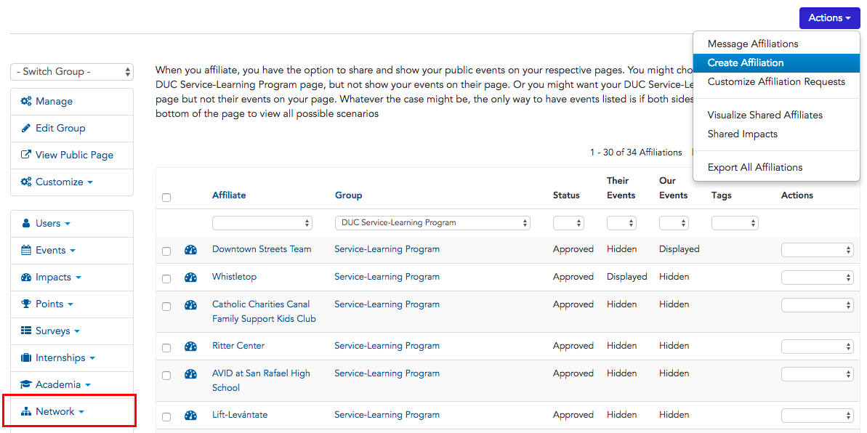
When you go into "Create" affiliate, you will find there are a few options. You can search for the group, hide groups that currently are outside of your network and location, or you can "add" your own.

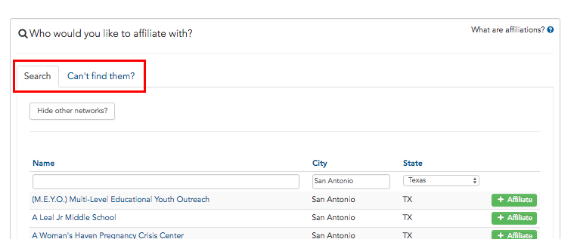
To add your own, you'll need to click on "Can't find them?" and you will be directed to the following screen: (press the Create button)

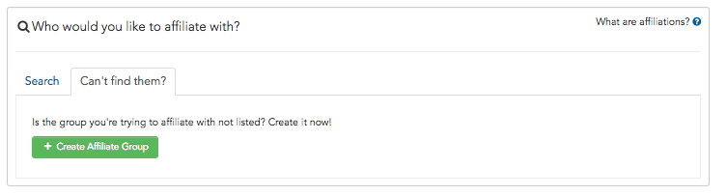
You'll then be routed to another page, where you’ll be asked to complete the process to input the details of the group you want to affiliate with.

Classes - Very often, classes available at your institution have a label that distinguishes itself as a particular type of course, such as a course focused on Service Learning, Experiential Learning, Community Based Learning, Community Based Research, etc.
It is best to think of a class like a subgroup – events can be placed in both subgroups and classes. Classes can use GivePulse to coordinate many different kinds of activities.
To further filter and determine the scope of work done inside the course, you may specify the primary focus of the course using one of the following descriptions:
Deliverable: The end product of the class, could include a project, presentation or something like a final reflection essay.
Placement: Part of the experience is to immerse the student and be placed with a community partner as a requirement, some institutions have required n number of hours for the placement.
Engaged Research: To work with faculty, staff or be empowered as a student to apply current research to address community issues and disparities.
Dashboard – There are three types of dashboards: your personal dashboard, Group Dashboard, and Event Dashboard. Your personal dashboard is accessible via the toolbox at the top of the page by clicking the Dashboard button. The group dashboard allows you access to all the navigation tools to manage your group. Here you can access your users, events, and impacts. You can also access other tools here, such as managing subgroups, affiliations, surveys, custom fields and more. If you are looking for a single place for event managers or even for you to see the status or details of the event, there is a specific Event Dashboard to provide you a one-stop shop. Depending on the type of Event, you will have a dashboard giving you a summary of the event, along with some key details and information related to the event (e.g., date, time, location). To access this dashboard, you can navigate to it via the "Manage Events" of your group, or if you are a specific event manager tasked to just oversee this one event, you can quickly navigate to the events you oversee by clicking "hi yourname", hovering over "My GivePulse" and selecting "Events I Manage." Below is an example of an event dashboard:
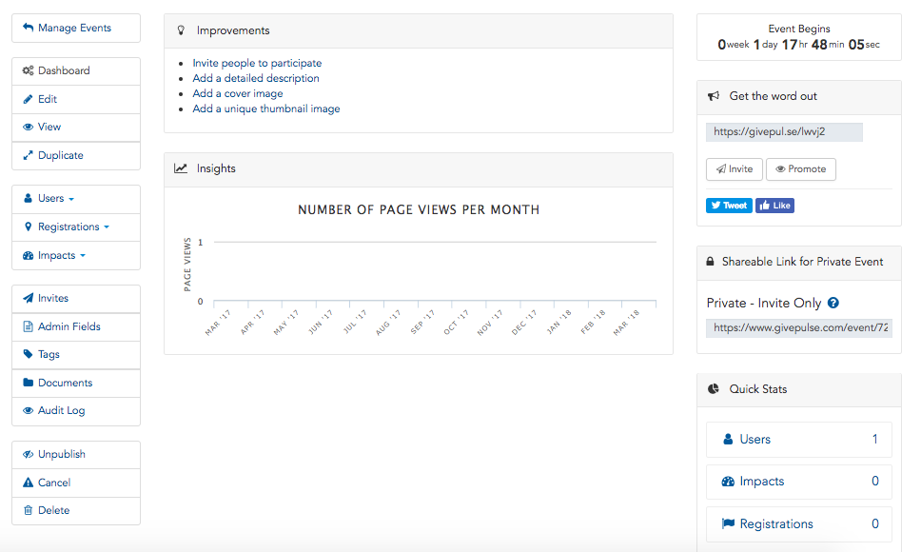

Documents - Documents enable administrators to upload and store PDFs, TXT, and images for storage and retrieval or for private and/or public consumption.
Documents may be saved and shared at a group level (i.e., members have access to this), or it can be tied directly to a user record (i.e., benefiting the administrator by centralizing all the data associated with a particular member). One example of such document may be a sign-up sheet for your organization that includes names, phone numbers, and email addresses.
When a document is stored per individual record (e.g., if you scanned some files for a volunteer and you wanted to keep track of it, you may go to the specific person's record, and upload the file).
- All files are private and tied to the user record
- Files are only visible to admins

Messages - GivePulse also allows users to segment and message all users in a way that streamlines communication.
By default, if you are an administrator overseeing a group or a subgroup, you have the abilities to message everyone or just the members of the group. Note: the difference here is that everyone includes those that aren't officially "members" but have interacted with your group in some capacity. There are many ways this can happen (e.g., they are "registered" to a public event your group hosted or have tracked "hours" with your group in the past).
To message all members or everyone in the group you can navigate to the "users" section and select "Message Members" or "Message Everyone." To message a subset of users, you can do so by "tagging" or "adding quicknotes" to these individuals via the "Manage User's” page.
If you would like to message a peer that you met or need to communicate with, you may find them in the members view of the group.
- The Members view in the group is located in the center of the group. This is a section with profile photos of all the members in the group.
- On the members view, there is a link "View All" which will direct you to a page displaying all the members.
- When clicking on the individuals profile image, you will be directed into their profile. On their profile there is a button to "message" the individual directly.

Network – The network consists of a main hub, followed by subgroups within the hub. In our case, the main hub is Iowa State University’s Community Engagement Center: Volunteer Portal. While administrator access rolls down in the network, data rolls up, allowing for tracking impacts across the state of Iowa through respective groups until it reaches a central figure. An example of how the network visualization works is as follows, where Community Engagement Center: Volunteer Portal is central and subgroups are branches of the central hub:
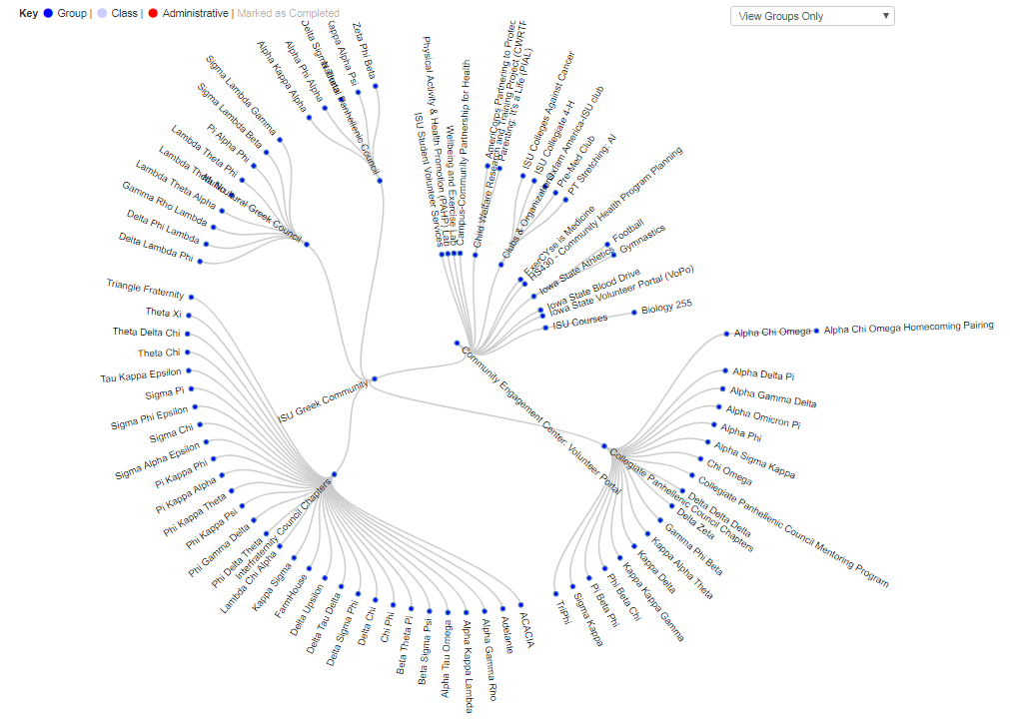
People - There are many users who become members, volunteers, registrants, etc. inside a group. As a member of a group, you are able to search and seek out your peers and message them. This will help cultivate relationships when helping the community.
Below is an example of what you may see in the group page, a section displaying people you may connect with.
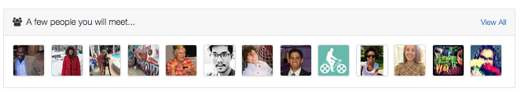
Registrations - When you are an event manager or administrator who wants to manually register someone to an event (i.e., enroll someone), you can do so via the Events Dashboard by choosing Registrations, then the Manual Register User option. With this option, you will have the ability to manually add new user details, select from existing users, or import a csv or excel file of users. Depending on how you set up the group (in the registration settings for the event), you might be required to fill in additional information specific to the event. For example, if you have an event where you require t-shirt size, cell phone, or other questions, since you are manually inputting this data in, you will have to fill this data out.
Video Tutorials

- Introduction to GivePulse - https://www.youtube.com/watch?v=p_HmJnK18lE
- User Dashboard - https://www.youtube.com/watch?v=CDcqwSiIJ3Q
- Basics of GivePulse for Administrators - https://www.youtube.com/watch?v=P6ipHsQNnOE
- Basics of GivePulse for Student Volunteers - https://www.youtube.com/watch?v=6jagyPWQ5FQ
- Basics of GivePulse for Community Partners - https://www.youtube.com/watch?v=3TEDM3FvxLU
- Basics of GivePulse for Faculty - https://www.youtube.com/watch?v=poSbS6Ccp3g
- How to manage users - https://www.youtube.com/watch?v=urr5oxn_TGA
- How to create an Event - https://www.youtube.com/watch?v=8QlG4xv4vCM
- How to manage Events - https://www.youtube.com/watch?v=Szft6rs7bsg
- How to manage Impacts - https://www.youtube.com/watch?v=rfV1P-LAebo
- Creating Classes - https://www.youtube.com/watch?v=EYySFc38sss
- Exporting Data - https://www.youtube.com/watch?v=tVP-2HU_mR8
- Configure Layout and Filter - https://www.youtube.com/watch?v=S6Oj6xDaOXE
- Custom Fields - https://www.youtube.com/watch?v=gBsQmirrqcM
- Archived Users - https://www.youtube.com/watch?v=0ROYTAYnw0g

To see more tutorial videos, check out the GivePulse YouTube @ https://www.youtube.com/channel/UCXguG4M_qcUddDKdGaFmfVA

To learn more about GivePulse, visit the About section at https://www.givepulse.com/about the F.A.Q. https://www.givepulse.com/faq
or Support http://support.givepulse.com

If you have any questions, please feel free to contact our team at:
givepulse@iastate.edu
uturn@iastate.edu
bmccurdy@iastate.edu

Thanks and happy networking!

